Final Project Report

AI-Powered Personalized Learning System



Project Supervisor

<< Dr. Saima Munawar>>

Submitted By

<< S25PROJECT63F44>>

<<Abdulrehman>> << BC220201712>>
<<Samra>> << BC220201726>>

Software Projects & Research Section,
Department of Computer Sciences,
Virtual University of Pakistan


CERTIFICATE

This is to certify that Abdulrehman (BC220201712), Samra (BC220201726) have worked on and completed their Software Project at Software & Research Projects Section, Department of Computer Sciences, Virtual University of Pakistan in partial fulfillment of the requirement for the degree of BS in Computer Sciences under my guidance and supervision.

In our opinion, it is satisfactory and up to the mark and therefore fulfills the requirements of BS in Computer Sciences.

Supervisor / Internal Examiner

Dr. Saima Munawar Supervisor,
Software Projects & Research Section,
Department of Computer Sciences
Virtual University of Pakistan

___________________
(Signature)

External Examiner/Subject Specialist
<<External Supervisor Name>>

___________________
(Signature)

Accepted By:

_____________
(For office use)

EXORDIUM

In the name of Allah, the Compassionate, the Merciful.

Praise be to Allah, Lord of Creation,
The Compassionate, the Merciful,
King of Judgment-day!

You alone we worship, and to You alone we pray for help,
Guide us to the straight path

The path of those who You have favored,

Not of those who have incurred Your wrath,
Nor of those who have gone astray.

DEDICATION

This project, AI-Powered Personalized Learning System, is dedicated to all learners and educators who inspire the pursuit of knowledge through innovation and perseverance. Their continuous efforts to make education more accessible and engaging have motivated the creation of this system, which aims to transform traditional learning into a personalized and intelligent experience. I also dedicate this work to my teachers, family, and friends for their unwavering support, encouragement, and belief in my abilities throughout this journey. Their guidance and motivation have been the foundation of my progress and success in completing this project.

ACKNOWLEDGEMENT

I would like to express my sincere gratitude to all those who contributed to the successful completion of my project, AI-Powered Personalized Learning System. First and foremost, I am deeply thankful to my supervisor for their valuable guidance, constructive feedback, and continuous encouragement throughout the development of this project. I also wish to acknowledge my teachers for their support and for providing the knowledge that laid the foundation for this work. My heartfelt thanks go to my family and friends for their patience, understanding, and motivation during challenging times. Their constant support has been a source of strength and inspiration, enabling me to complete this project successfully.
PREFACE
The AI-Powered Personalized Learning System project has been developed to explore how artificial intelligence can enhance the educational experience by adapting to individual learners’ needs, preferences, and progress. This preface provides an overview of the motivation, objectives, and structure of the project. The primary goal is to create a system that personalizes learning paths, provides intelligent feedback, and helps both students and instructors achieve better outcomes through data-driven insights. This report presents the research, design, development, and implementation processes involved in building the system. It reflects my effort to integrate theoretical knowledge with practical application, contributing to the advancement of modern learning technologies.

TABLE OF CONTENTS

CHAPTER NO. 1
gathering & Analyzing info 10

1.1 Introduction

1.2 purpose

1.3 scope

1.4 definitions, acronyms and abbreviations

1.5 Project requirements

1.5.1 Functional Requirements

1.5.2 Non-Functional Requirements

1.6 use cases and usage scenarios

1.6.1 Use Case Diagrams

1.6.2 Usage Scenarios

1.7 Development Methodology

1.7.1 Chosen Methodology

1.7.2 Reasons for Chosen Methodology
1.7.2 Work Plan (Gantt Chart)
1.7.2 Project Schedule (Submission Calendar)

CHAPTER NO. 2
designing the project 12

2.1 Introduction

2.2 purpose

2.3 scope

2.4 definitions, acronyms and abbreviations

2.5 Architectural Representation (Architecture Diagram)

2.6 Dynamic Model: Sequence Diagrams

2.7 Object Model/Logical Model: Class Diagram

2.8 Database Model (Database Diagram)

2.9 Graphical User Interfaces

Chapter no.3
DEvelopment 13
3.1 Development plan (Architecture Diagram)

<<Dear Students, you have to take special care of page numbers, which are written against each Chapter and sub headings. You have to mention your own page numbers and correct one against each document heading. Make proper table of contents. Remember that if there are any new headings or you have included more headings in your documents then you also have to write these in table of contents and modify table of contents according to your documents material>>

<<Dear Students, before starting each chapter the following would be the title page for each chapter on a separate page>>

CHAPTER 1
Gathering & Analyzing Info

  - Introduction
This project aims to develop an AI-driven personalized learning system that adapts to students' learning styles, strengths and weaknesses. The system will store student progress data, analyze their performance using AI and recommend customized learning materials, quizzes and study plans. It will use machine learning algorithms to predict areas where students need improvement and provide intelligent tutoring through chatbots and automated assessments.

  - purpose

The purpose of the AI-Powered Personalized Learning System is to revolutionize the traditional learning process by integrating artificial intelligence into education. The system aims to provide a personalized and adaptive learning experience for each student by analyzing their learning patterns, progress, and performance. Through data-driven insights, it identifies individual strengths and weaknesses, ensuring that students receive targeted learning materials, customized quizzes, and relevant study plans that match their unique needs. By doing so, it enhances learning efficiency, motivation, and overall academic performance.
Furthermore, the project seeks to assist educators in monitoring student progress more effectively through intelligent dashboards and analytics tools. Teachers can gain a deeper understanding of each learner’s development, allowing them to offer timely support and guidance. The integration of AI-powered chatbots and automated assessments reduces manual workload, making the educational process more interactive and efficient. Ultimately, this system strives to create a smarter, data-informed learning environment that bridges the gap between technology and education, empowering both students and instructors to achieve better learning outcomes.

  - scope

The scope of this project is to preparation and construct up an AI-driven adapted education system that cater to the exclusive learning requirements of students by adapt to their personality knowledge styles, strengths, and weaknesses. The system will give an active and quick to respond learn understanding throughout the use of complex mechanism scholarship algorithms and accepted language giving out technique. It will comprise a locked user confirmation machine to tolerate contact to students, teachers, and administrators, ensure that every one user has the suitable level of access and control.
A middle module of the system will be its facility to accumulate and administer a complete student database. This will contain tracking progress, analyzing presentation, and maintain a narration of knowledge behavior. Based on this data, the AI will make available adapted recommendation, generate adaptive satisfied, and recommend learning plans tailored to each student’s needs. Furthermore, the system will be capable of create programmed quizzes and assessments that goal precise areas where the student requires improvement, making learning extra resourceful and paying attention.
To improve interactivity and maintain, an AI-powered chatbot will be included to help students among their questions in real-time using ordinary language accepting. Teachers will be making available with an enthusiastic control panel to monitor student evolution, estimate presentation metrics, and formulate knowledgeable decisions on the subject of lessons. Furthermore, the system will make sure the protected store of student data and learning satisfied to continue confidentiality and truthfulness.

  - definitions, acronyms and abbreviations

SRS: Software Requirements Specification

Web: Website

SQL: Structured Query Language

1.5 Project requirements

Functional and non Functional Requirements:

For Students
- Usability:
The system be supposed to have a responsive and user-friendly boundary that makes it straightforward for students to follow the map satisfied, pathway their knowledge progress, and network with the AI chatbot exclusive of requiring technological knowledge.
- Performance:
The organizations have to weight made to organize comfortable and assessments speedily (within 2 seconds), smooth through peak custom period.
- Availability:
The raised area be supposed to be reachable 24/7 so students can learn at their have possession of speed and expediency.
- Accessibility:
The classification be supposed to pursue convenience standards (such as WCAG 2.1) to maintain students with illustration, hearing, or motor disabilities.
- Mobile Compatibility:
Students must be competent to admission the system like a dream on Smartphone’s and tablets with complete functionality.
For Teachers
- Scalability:
The arrangement should maintain a huge number of teacher accounts and handle numerous undergraduate groups exclusive of presentation dreadful conditions.
- Data Visualization:
The teacher instrument section obligation demonstrates performance metrics and student improvement obviously, using graphs, charts, and filters.
- Reliability:
The coordination should decrease downtime (target 99.9% uptime) to make certain teachers can admittance it whenever desirable, mainly previous to exams or assessments.
- Response Time:
Teachers be supposed to understanding negligible impediment (under 3 seconds) when generating intelligence or reviewing class agreement analytics.
- Security:
Teachers' right to use to responsive student data should be role-based and secluded to put a stop to unauthorized changes or introduction.

For Administrators
- Maintainability:
The structure should be uncomplicated to modernize and continue, allowing administrators to supervise contented, permissions, and scheme kindling professionally.
- Security & Privacy Compliance:
The policies have got to fulfill with data protection set of laws (e.g., GDPR, FERPA) for storing and dispensation undergraduate in sequence strongly.
- Audit Logs:
The arrangement should keep up comprehensive logs of all user proceedings and changes for intelligibility and answerability.
- System Monitoring:
Administrators should be capable to supervise system physical condition, attendant status, and data backup schedules from first to last a management panel.
- Interoperability:
The organization obligation is accomplished of integrating by means of exterior learning tools and services during APIs, supporting horizontal data switch over.

1.6 use cases and usage scenarios
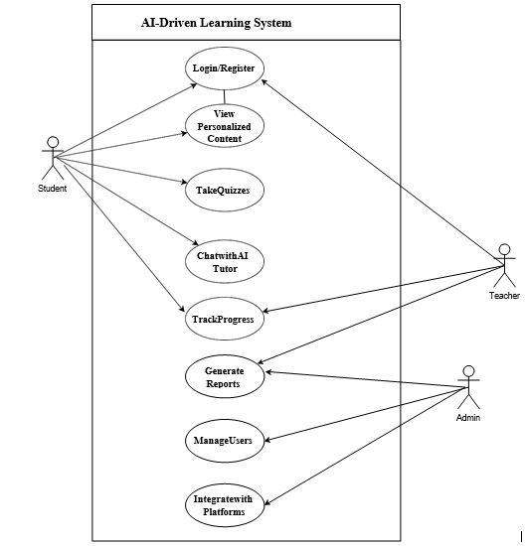

1.6.1 Use Case Diagrams

1.6.2 Usage Scenarios

Use Case: UC001: User Authentication:
Heading | Description
Actions | 1. User enters identification.  2. System validates user data.  3. User is established access.
Description | These use cases handle the verification procedure, allowing students, teachers, and administrators to access the system.
Alternative Paths | Invalid qualifications effect in a repeat punctual, and after several failed attempts, access is denied.
Pre Conditions | Users have to include valid recommendation.
Post Conditions | User is moreover decided access or deprived of based on the authority of the credentials.
Author | S25PROJECT63F44
Exceptions | Unacceptable credentials outcome in a login not a success.

Use Case: UC002: Student Database Management:
Heading | Description
Actions | 1. System stores student data.  2. System track development and knowledge history.
Description | Manages and tracks student growth, together with learning record and performance.
Alternative Paths | Data possibly will be unsuccessful to be entered or despoiled.
Pre Conditions | Systems have got to be situating up to store up and follow student data.
Post Conditions | Data is effectively stored, and student evolution is tracked.
Author | S25PROJECT63F44
Exceptions | Data entry failure or tainted information might take place.

Use Case: UC003: Personalized Learning Recommendations:
Heading | Description
Actions | 1. System analyzes learner presentation.  2. AI suggests modified learning equipment
Description | The AI system provides modified learning comfortable suggestion base on the student's routine and preference.
Alternative Paths | AI could fail to offer applicable or adapted recommendations.
Pre Conditions | System is obliged to contain data on student concert and education preferences.
Post Conditions | Student receives personalized education material based on AI investigation.
Author | S25PROJECT63F44
Exceptions | AI may be unsuccessful to afford the right or mainly related suggestions.

Use Case: UC004: Automated Quizzes and Assessments:
Heading | Description
Actions | 1. System analyzes student weakness.  2. System generates personalized quizzes.
Description | Based on the student’s weaknesses, the scheme creates and assigns quizzes or assessments.
Alternative Paths | Quizzes possibly will not support through the student’s authentic weaknesses.
Pre Conditions | Student should have concluded preceding learning behavior for truthful assessment.
Post Conditions | Customized quizzes are generated and assigned to the student.
Author | S25PROJECT63F44
Exceptions | System may possibly fail to cause the accurate or important quiz questions.

Use Case: UC005: AI-Powered Chatbot Tutor:
Heading | Description
Actions | 1. Student asks a question.  2. Chatbot uses NLP to recognize and answer.
Description | The AI-powered chatbot assists students by responding to queries using Natural Language Processing (NLP).
Alternative Paths | If the chatbot do not appreciate the question, it force ask for explanation or submit to a teacher.
Pre Conditions | The chatbot should be lively and complete to be given queries from students.
Post Conditions | Student receives a reply starting the chatbot or gets redirect to a teacher for additional assistance.
Author | S25PROJECT63F44
Exceptions | Chatbot could fail to appreciate or react exactly.

Use Case: UC006: Teacher Dashboard:
Heading | Description
Actions | 1. Teacher logs into the control panel.  2. Teacher views student development and performance metrics.
Description | The teacher uses the console to supervise student progress, performance, and other interconnected metrics.
Alternative Paths | The instrument panel may fail to weight, or present incorrect data.
Pre Conditions | Teacher is required to be logged in and have authorization to access the control panel.
Post Conditions | Teacher gains access to student records and presentation metrics.
Author | S25PROJECT63F44
Exceptions | Dashboard may fail to load or demonstrate obsolete data.

Use Case: UC007: Secure Data Storage:
Heading | Description
Actions | 1. System stores instructive possessions and student data strongly.  2. Data is encrypted.
Description | This use container ensures protected storage space of educational property and student data with encryption.
Alternative Paths | Data might not be strongly stored or may be uncovered due to a violation.
Pre Conditions | System be required to have encryption and locked storage capability.
Post Conditions | Data is stored steadily, with encryption functional to protect student information.
Author | S25PROJECT63F44
Exceptions | Security commit a breach, data loss, or corruption might happen.

1.7 Development Methodology

1.7.1 Chosen Methodology

For this project, we've selected the VU Process Model, which combines elements of equally the Waterfall and Spiral models. This advance provides a good equilibrium between prepared preparation and suppleness, which is necessary for the growth of the AI-driven personalized learning system.
Here’s a breakdown of how we’ll be applying the VU Process Model:

1. Requirements Gathering (Waterfall Approach):
First, we start by assembly all the supplies. This means conversation to students, teachers, and administrators to recognize their needs and outlook from the system. The Waterfall technique works well here since it helps us generate a concrete foundation with a clear, acknowledged set of supplies. This way, we identify closely what the system needs to do earlier than jumping into design and development.

2. Design and Prototyping (Spiral Approach):
Once we include the requirements, we progress into the design phase. Instead of calculating the whole lot upfront, we take an iterative advance like the Spiral model, which allows us to construct prototypes untimely on. This is useful for difficult ideas and receiving feedback from users as regards what works and what doesn’t. For instance, we can prototype the AI chatbot and adapted content features, test them, and distill based on what we learn from authentic users.

3. Development (Waterfall + Spiral):
Now, it’s instance to construct the system. We track the Waterfall model for thorough development, ensuring the features are build in a prepared way. However, we keep the curved model in intelligence by breaking the expansion into slighter cycles. Each cycle lets us assessment progress, test, and adjust before touching on to the next part. This helps make sure that we’re continually civilizing the system and addressing any issues as they take place.

4. Testing and Validation (Spiral Approach):
Testing happen all throughout the development, not immediately at the end. The Spiral model encourages common testing, which resources we’re validating the system’s functionality, user experience, and performance in iterations. This also includes feedback from users through the testing phase, ensuring the system meets their outlook before we move on to operation.

5. Deployment and Maintenance (Waterfall + Spiral):
After expansion and methodical testing, the system is prepared to be organizing. But, since the Spiral model encourage continuous development, we don’t just discontinue there. We arrangement for customary updates and maintenance to recover features like AI recommendations or chatbot responses. We’ll keep monitoring the system, congregate feedback, and improve the arrangement throughout expectations iterations.

Why the VU Process Model?
The grouping of Waterfall and Spiral models makes common sense for this project because it gives us a prearranged move toward to hold the complication of building an AI-powered system whereas also allowing for suppleness and permanent improvement. It ensures we hang about on track with understandable goals, except it also lets us regulate rapidly as we discover supplementary throughout every one phase.
In short, the VU Process Model gives us the most excellent of both worlds—structured documents from Waterfall and iterative improvement from Spiral—making it a perfect alternative for increasing this modified knowledge system.

1.7.2 Work Plan (Gantt Chart)
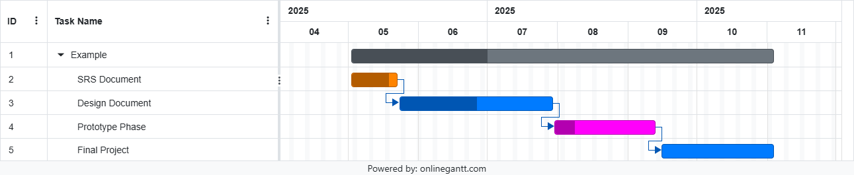
1.7.2 Project Schedule (Submission Calendar)
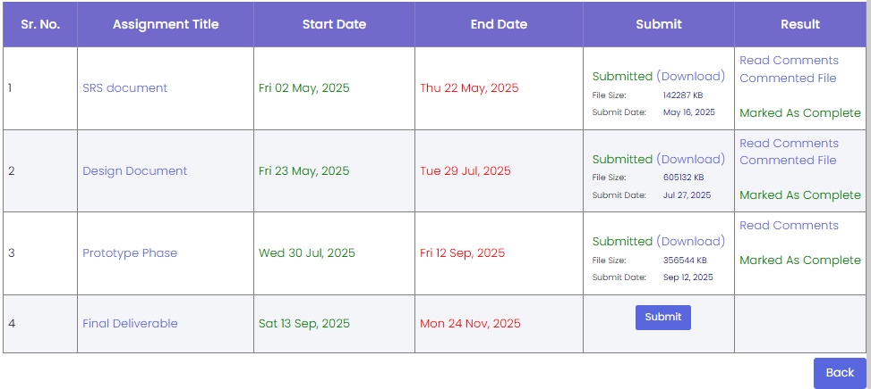

CHAPTER 2
Designing the Project

2.1 Introduction

The AI-Powered Personalized Learning System is an advanced informative stage that trusts Artificial Intelligence (AI), Education Technology, and Database Management to improve student learning involvements concluded personalization. In today's fast-evolving numerical education scenery, students often face contests due to broad and one-size-fits-all education properties. This project discourses that matter by presenting a system skilled of adjusting learning content based on individual presentation, partialities, strengths, and faintness.
The goal of this structure is to offer a shrewd and communicating knowledge situation wherever scholars accept handmade commendations, automated quizzes, and real-time funding from an AI-powered chatbot. The system endlessly studies after user contact and advancement data by means of engine learning procedures to progress the correctness and bearing of its proposals. Teachers and administrators also profit from progressive nursing tools and analytics dashboards that proposal profound insights into student performance and abstract development.
This project document affords a complete plan of the system’s technical and logical structure. It defines the important design workings and attends as a foundational situation for application and expansion. The design components included in this document are:
- Entity Relationship Diagram (ERD): Signifies the database structure including entities such as Student, Teacher, Quiz, Course, PerformanceReport, etc., and the relationships between them.
- Sequence Diagrams: Demonstrate how system components interrelate over time to whole various processes such as user login, quiz generation, and chatbot communication.
- Architecture Design Diagram: Summaries the overall system architecture including client-side interface, backend services, database, and AI/NLP modules.
- Class Diagram: Defines the object-oriented structure of the system, presentation the main classes, their attributes, methods, and relationships.
- Database Design: Defines the scheme of the database including tables, fields, primary and foreign keys, and normalization decisions.
- Interface Design: Delivers models and layouts for user interfaces for students, teachers, and administrators.
- Test Cases: Lists planned tests that will be used to validate the system's performance under different conditions, ensuring functional correctness, usability, and performance.
The system is built using modern and scalable technologies:
- Backend: Python with Django or Flask, or alternatively Node.js for API services.
- Frontend: React.js or Vue.js for building interactive and responsive UI.
- Database: PostgreSQL, MongoDB, or Firebase for supple and competent data storage.
- AI/ML Libraries: TensorFlow, PyTorch, or Scikit-learn for model exercise and calculations.
- NLP Tools: spaCy, NLTK, or OpenAI GPT for chatbot and language empathetic.
- Cloud Integration: AWS or Google Cloud services for installing AI models and management ascendable substructure.
This document also attends to confirm that all stakeholders, including developers, samples, teachers, and project managers, have a shared understanding of how the system will purpose and how its workings are intended to work composed. It is expected that team followers have completed a short requirement sequence on basic AI, engine learning, and system design to successfully recognize and underwrite to this project.
In summary, this article marks the change from high-level classification condition to thorough design, which directors the expansion and future development of a smart, tailored, and AI-integrated educational platform.

2.2 purpose

The purpose of this Design Document for the AI-Powered Personalized Learning System is to provide a comprehensive technical blueprint that guides the system’s development and implementation. It outlines the structural, functional, and design aspects necessary to transform the conceptual framework into a fully operational application. This document ensures that all team members—including developers, designers, testers, and project managers—share a unified understanding of the system’s architecture, database design, interface layouts, and AI integration strategies. By clearly defining each component, interaction, and workflow, the design document serves as a foundation for consistent development, smooth collaboration, and effective decision-making throughout the project lifecycle.

2.3 scope

The scope of this Design Document encompasses the complete system design and its integration across various modules such as the backend, frontend, AI/ML engine, NLP chatbot, and database management. It specifies the use of modern technologies and frameworks including Python, Django, React, TensorFlow, and MongoDB, ensuring scalability, performance, and adaptability. The document covers Entity Relationship Diagrams (ERD), Sequence Diagrams, Class Diagrams, and Architecture Design to visualize system components and their interactions. Additionally, it includes database schema details, interface mockups, and test cases to validate functionality and reliability. The scope also extends to ensuring that the design supports personalization, security, and intelligent learning features, ultimately guiding the development of an innovative, AI-driven educational platform.

2.4 definitions, acronyms and abbreviations

DD: Design Document

Web: Website

SQL: Structured Query Language

2.5 Architectural Representation (Architecture Diagram)

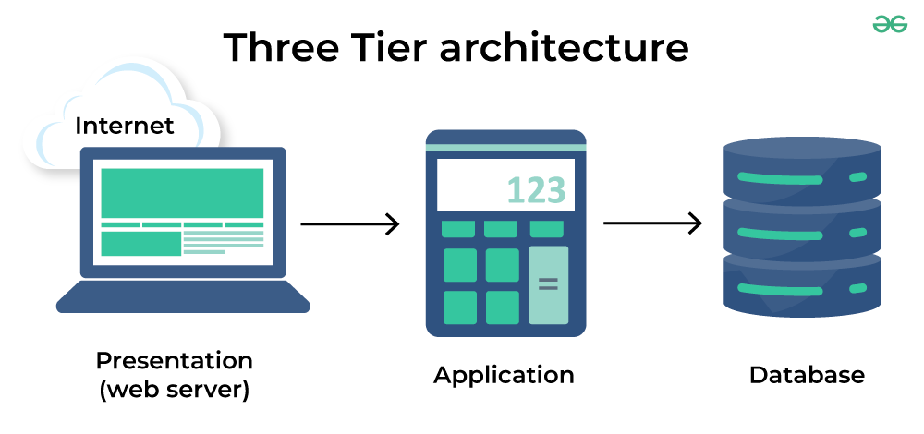

2.6 Dynamic Model: Sequence Diagrams
Users and Resources – Sequence Diagram:
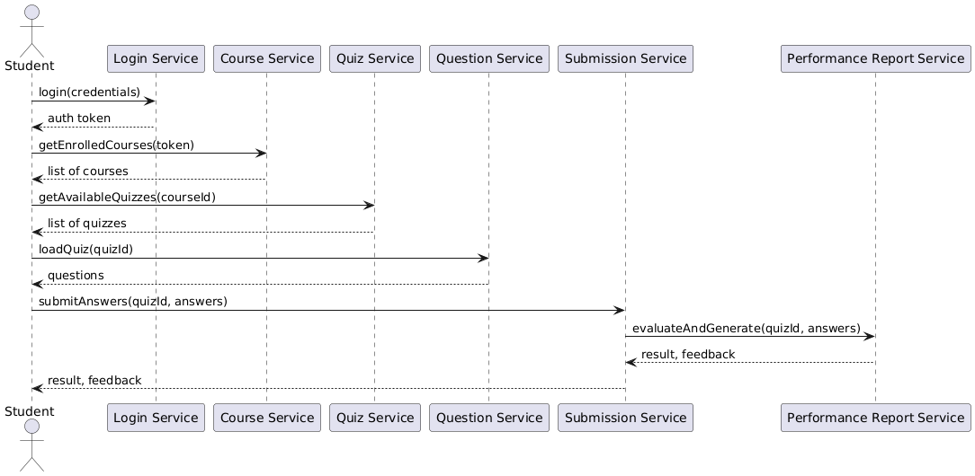
Admin Diagram:
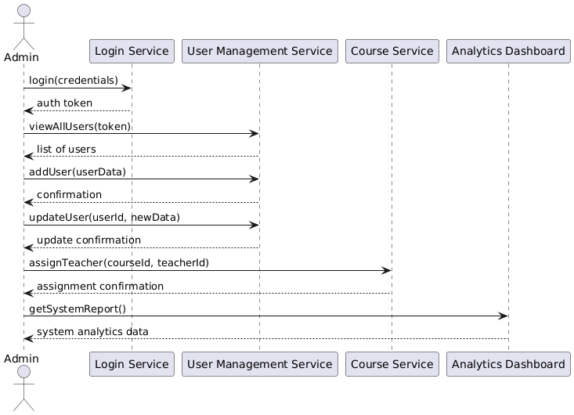

2.7 Object Model/Logical Model: Class Diagram
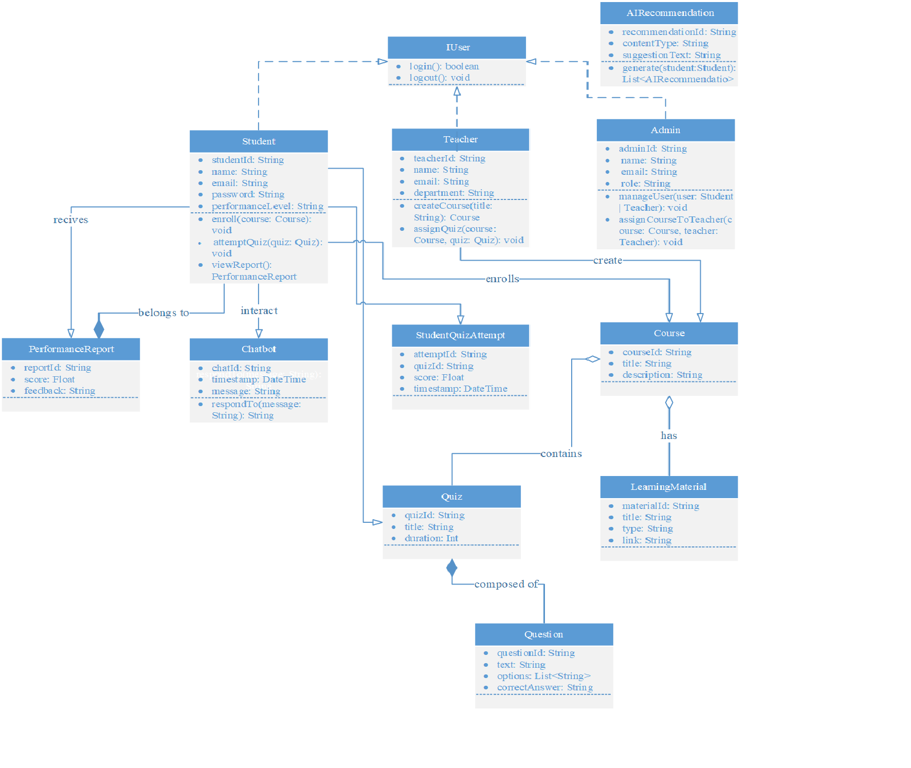

2.8 Database Model (Database Diagram)
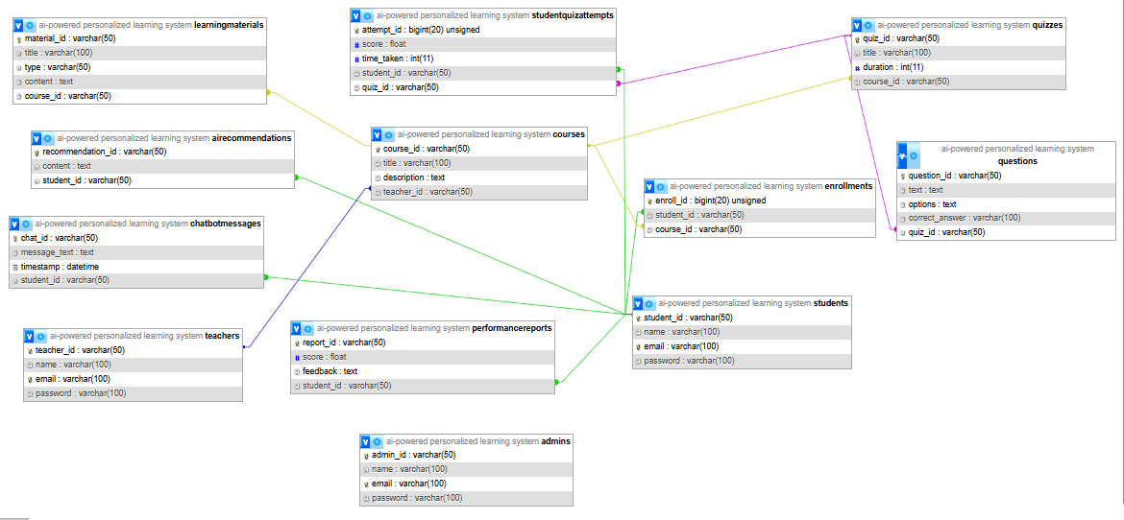

2.9 Graphical User Interfaces

- Register:
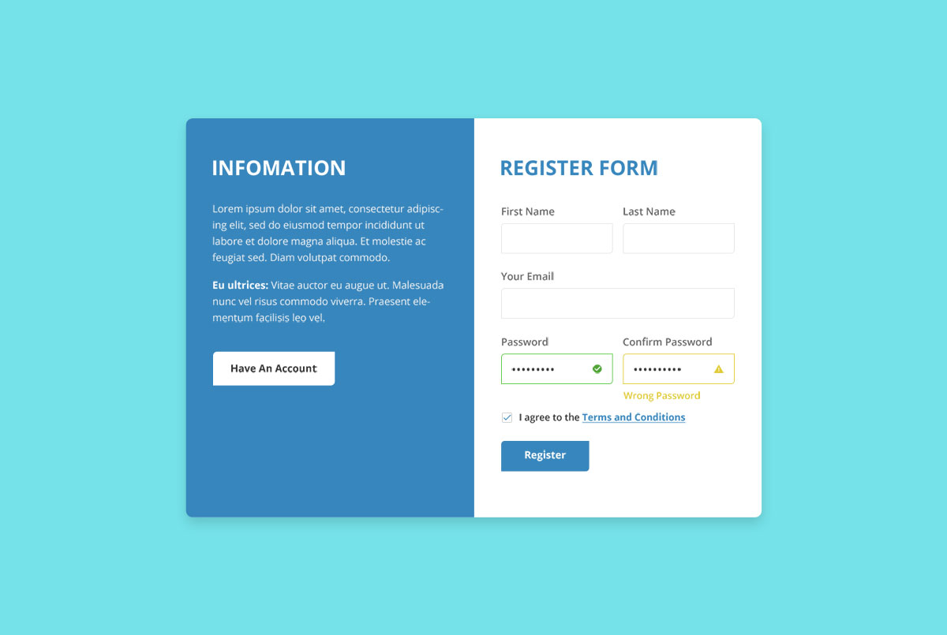

- Login:

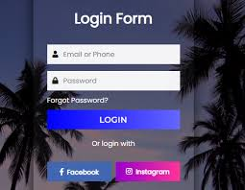

CHAPTER 3
Development

3.1 Development plan (Architecture Diagram)

REFERENCES

Youtube: https://www.youtube.com/@ThapaTechnical
W3School:
https://www.w3schools.com

Cs403: Book for Database

Cs304: Book for Classes and Class diagram

APPENDIX

Chapter 1 | Introduction and Analysis
Chapter 2 | Designing Phase
Chapter 3 | Architecture Phase

